PDC Lab 2
Advait Deochakke
20BCE1143 – 2 August ‘22

Question 1: Array Addition using parallel for
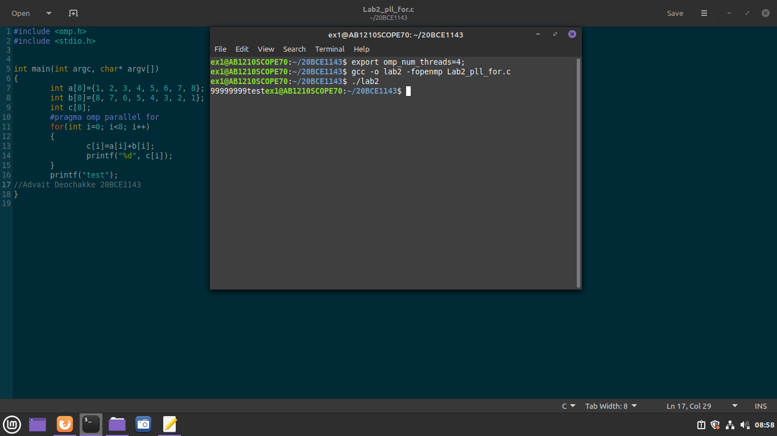
#pragma omp parallel for
for(int i=0; i<8; i++)
{
c[i]=a[i]+b[i];
printf("%d", c[i]);
}

Question 2 & 3: Sample for Shared and Private Variable
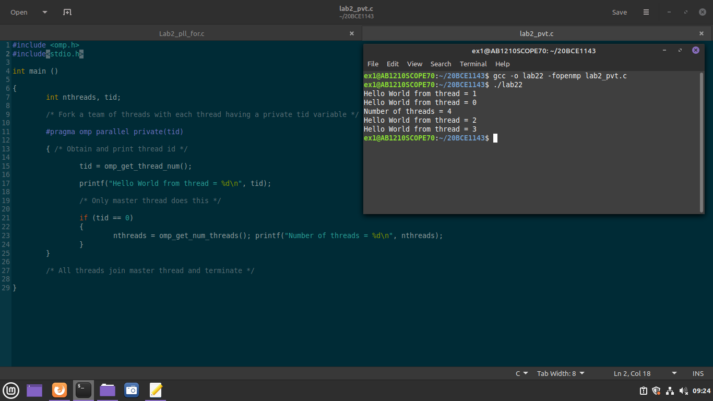
#include <omp.h>
#include<stdio.h>
int main ()
{
int nthreads, tid;
/* Fork a team of threads with each thread having a private tid variable */
#pragma omp parallel private(tid)
{ /* Obtain and print thread id */
tid = omp_get_thread_num();
printf("Hello World from thread = %d\n", tid);
/* Only master thread does this */
if (tid == 0)
{
nthreads = omp_get_num_threads(); printf("Number of threads = %d\n", nthreads);
}
}
/* All threads join master thread and terminate */
}

Question 4: Array addition using parallel for with a, b, c as private arrays
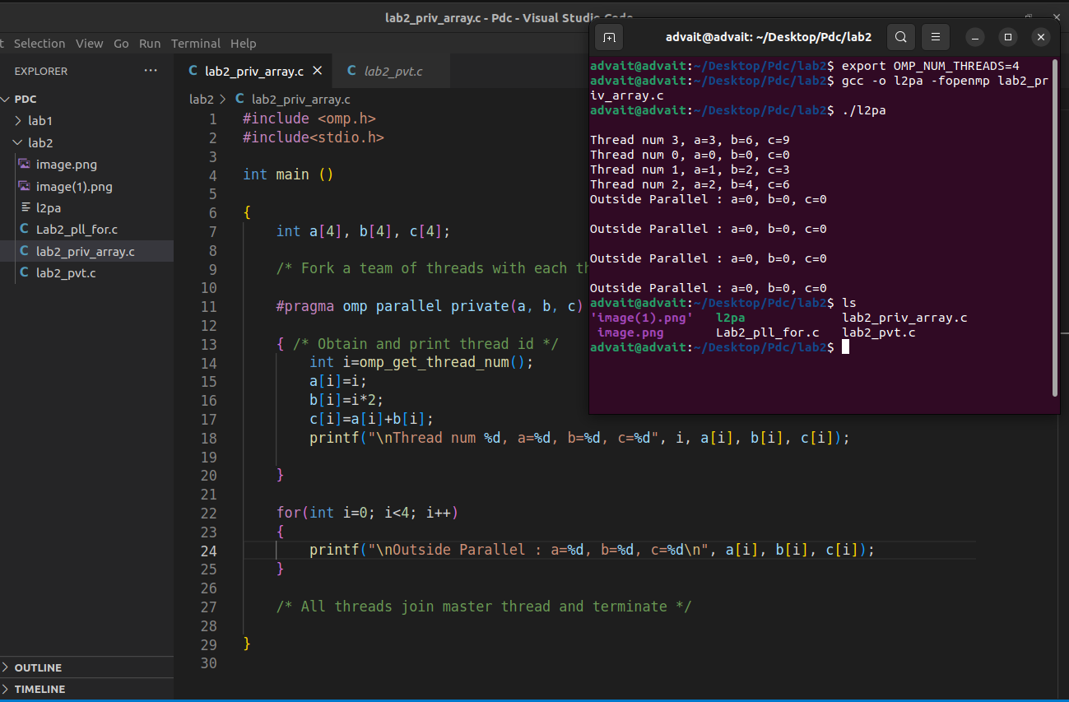
#include <omp.h>
#include<stdio.h>
int main ()
{
int a[4], b[4], c[4];
/* Fork a team of threads with each thread having a private tid variable */
#pragma omp parallel private(a, b, c)
{ /* Obtain and print thread id */
int i=omp_get_thread_num();
a[i]=i;
b[i]=i*2;
c[i]=a[i]+b[i];
printf("\nThread num %d, a=%d, b=%d, c=%d", i, a[i], b[i], c[i]);
}
for(int i=0; i<4; i++)
{
printf("\nOutside Parallel : a=%d, b=%d, c=%d\n", a[i], b[i], c[i]);
}

/* All threads join master thread and terminate */
}

Question 5: Parallelize addition and subtraction of two integer variables a and b

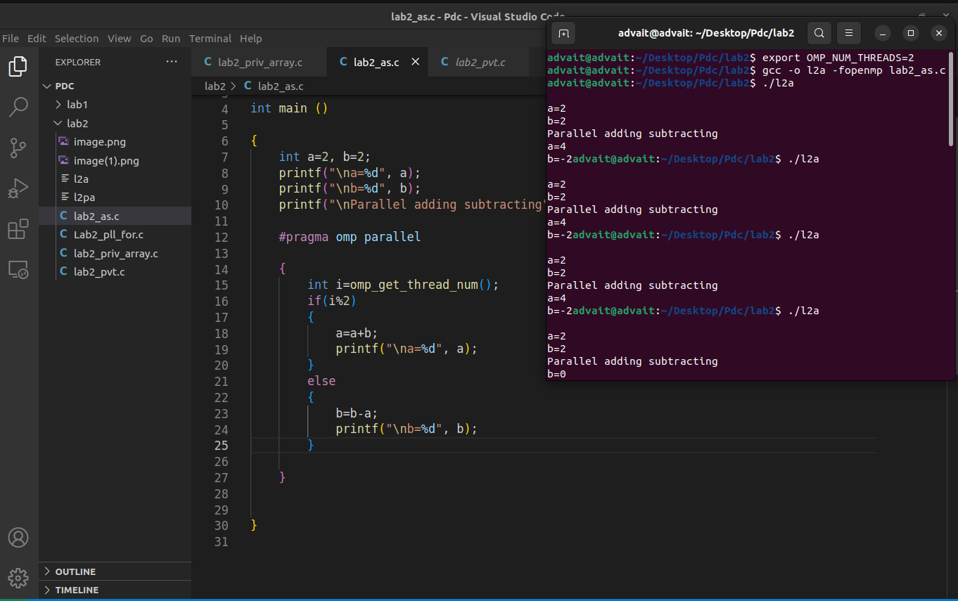
#pragma omp parallel

{
int i=omp_get_thread_num();
if(i%2)
{
a=a+b;
printf("\na=%d", a);
}
else
{
b=b-a;
printf("\nb=%d", b);
}

}

